# Purpose

***Advocating For Your Child in School:***

***Building a Partnership for Success***

# Workshop Outcomes

• • •

1. Understand how to get the school system on your side and practice the communication skills that will help you be successful.
2. If things go sideways, how do you get your relationship back on track?
3. Increase the chances your child will get what s/he needs
4. Understand the system your child’s teacher and principal works in
5. Learn how you contribute to the success, or lack of success, of your child’s school experience

|  |  |  |  |
| --- | --- | --- | --- |
|  |  |  |  |

This workshop focuses on positive and proactive methods parents can use to create the best working relationships with their child's school. By employing the skills covered in this workshop, and working with teachers and principals with an appreciation of the constraints they face, parents learn how they can work with schools to benefit their children.

|  |  |
| --- | --- |
| *When* | Tuesday Oct 18 6:30 – 9:30 pm  or  Thursday Nov 17, 6:30 – 9:30 |
| *Where* | The Silk Purse Arts Center, 1570 Argyle Avenue, West Vancouver [(Go to Google Maps)](https://www.google.ca/maps/place/1570+Argyle+Ave,+West+Vancouver,+BC+V7V+1A1/@49.3271127,-123.1604093,17z/data=!3m1!4b1!4m5!3m4!1s0x54866e1a647144b1:0xe0f5fc50829684e7!8m2!3d49.3271092!4d-123.1582206) Metered street parking. |
| *Target Audience* | Parents who want to create effective relationships with school staff. |
| *Cost* | FREE, thanks to the support of the Edith Lando Charitable Foundation and Mathieson Family Foundation |
| *Presented By* | Carmen Farrell, Executive Director: Social, Emotional and Empathy Development Society  www.seedsociety.ca |

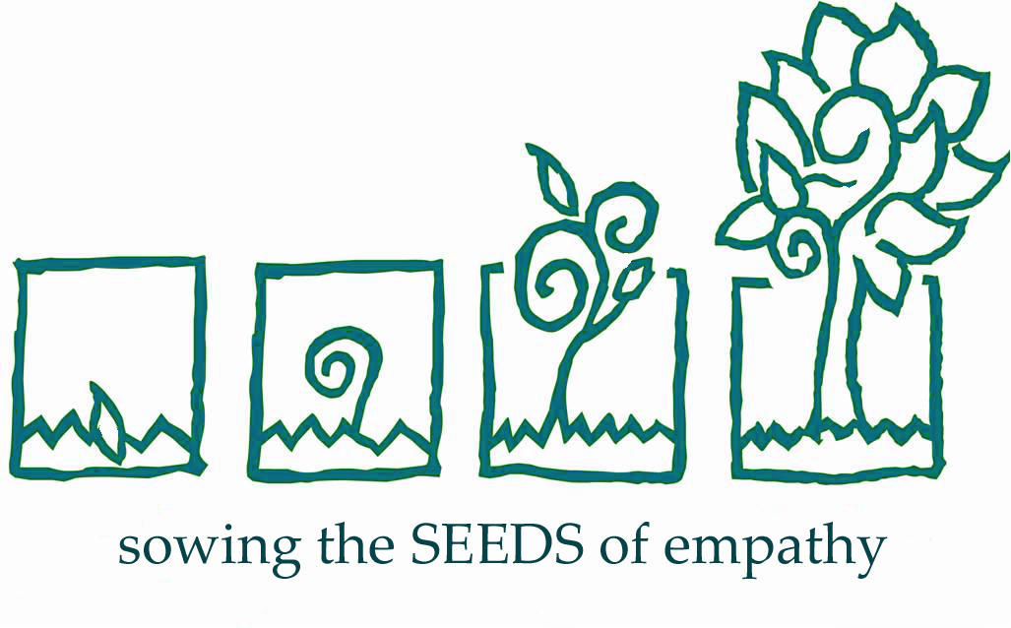

How to Register:

Pre-registration required, space limited.

Email:  [info@seedsociety.ca](mailto:%20info@seedsociety.ca)

